EI_maper

# About

EI_maper – editor of *.MOB and *.MPR files for the game Evil Islands.

# Interface

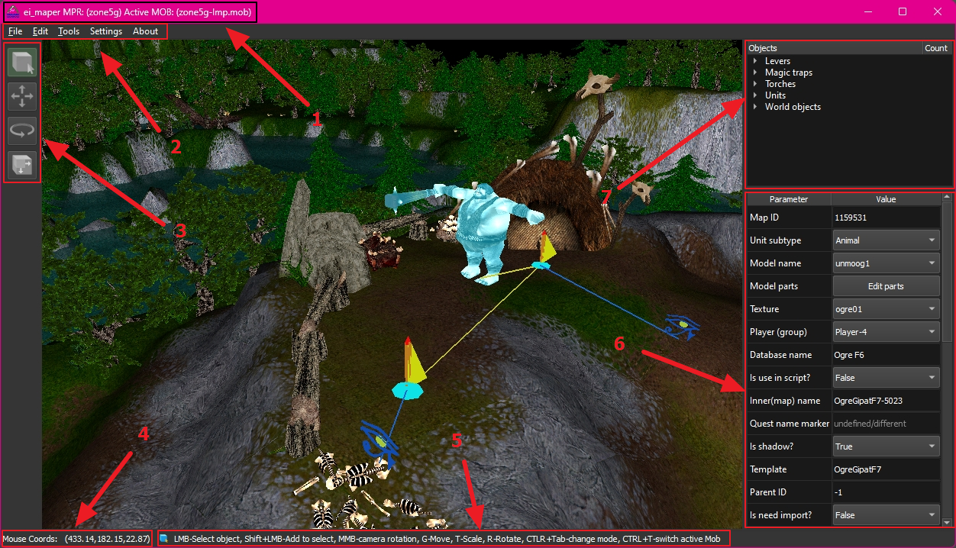

1. name of the opened map (*.MPR) and the active file with objects (*.MOB)
2. toolbar
3. control keys (currently only a visual role, showing the current type of editing)
4. mouse coordinates projected on the landscape surface
5. hint on hotkeys of the current editing mode
6. table of parameters of the selected object
7. tree of objects of the loaded *.MOB file.

# Options

At the first start you need to select the path to the resource (*.RES) files of the game with figures and textures. Several such files can be selected (for example, when editing mods). For several files, the important value is its sequence number, because in case of conflicting names, the figure or texture that is found first will be selected. The order can be changed with the Up and Down keys.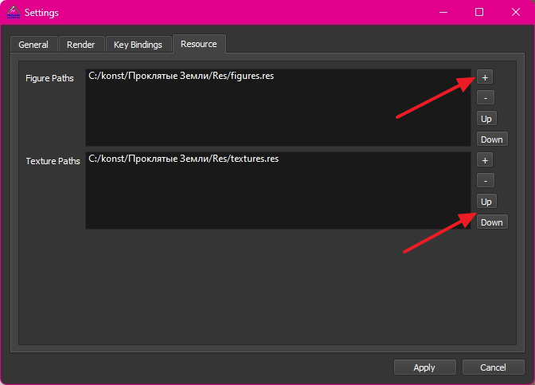

After selecting the files and clicking Apply, the changes will be saved. You can reopen the settings window from the Settings->Open tool menu.

First steps

After specifying the paths to the resource files, you can open the game zones. The first to be opened is always the landscape - this is the *.MPR file. Then you can open *.MOB files in unlimited number. As an example, we will use zone18 from the original game. After opening zone18.mpr and zone18.mob the following will happen: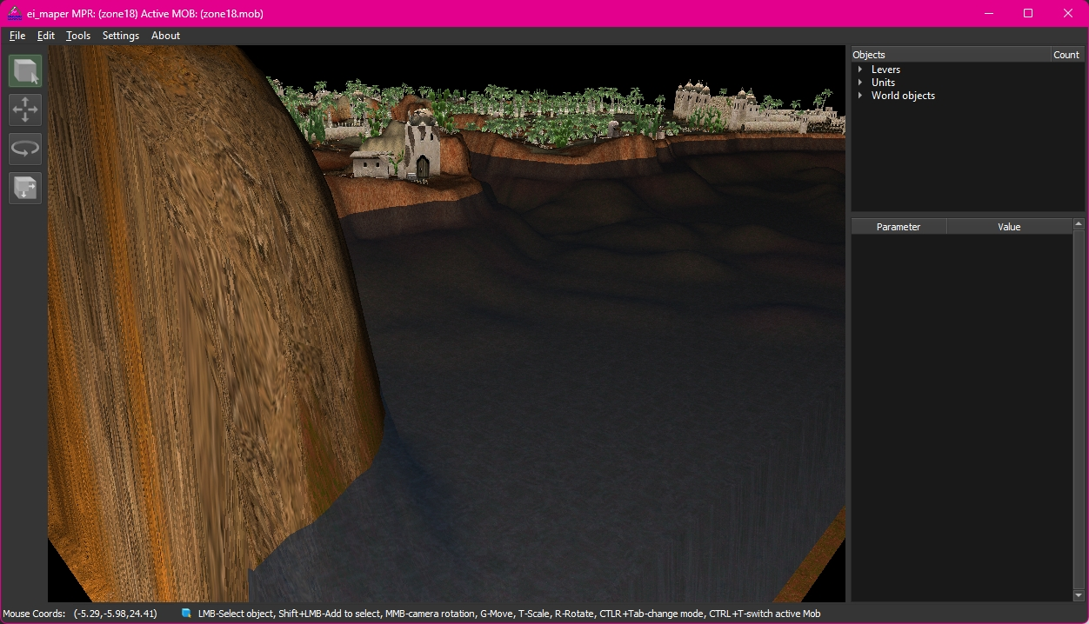

The keys W,A,S,D,Q,E and the middle mouse button for rotation are used to move around the game area. In addition, the mouse wheel can be used to change the current height instead of the Q,E keys.

To select objects, use mouse click or frame selection (on the left mouse button)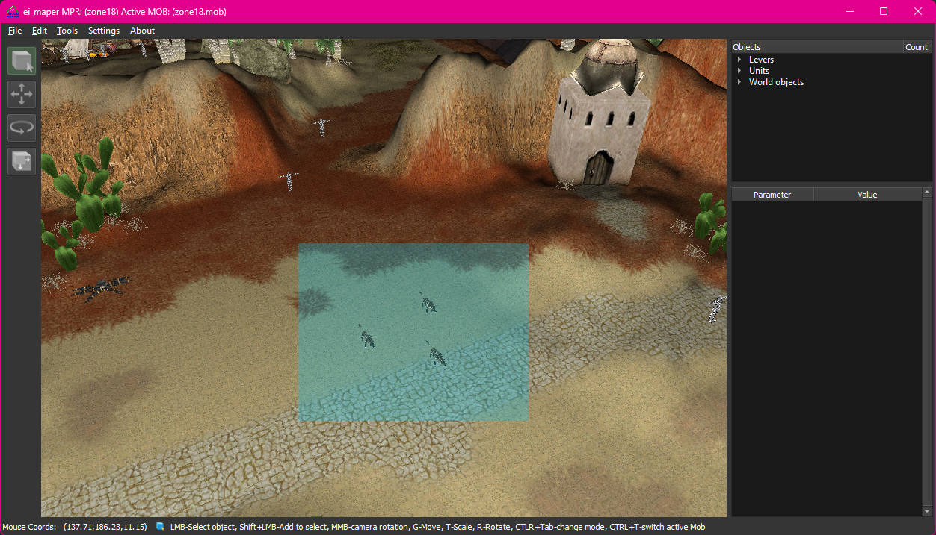

You can deselect by clicking on the free area with the left mouse button.

You can add/remove selection by holding down the SHIFT key.

To return the focus to the 3D area, for example, from the parameters or search window, it is recommended to use the right mouse button, so as not to reset the current selection of objects.

When loading the second *.MOB file, it will be selected as the current one and access to the previous *.MOB file will be limited: objects will be visible, but they cannot be selected or edited. The CTRL+T key combination is used to change the active *.MOB file. The active *.MOB file is displayed in the window header. Unloading of the active *.MOB file is available using the U hotkey.

*.MOB files have both parameters and script part. To access them you can use CTRL+M or call them from the Edit->Mob parameters menu. The interface looks like this: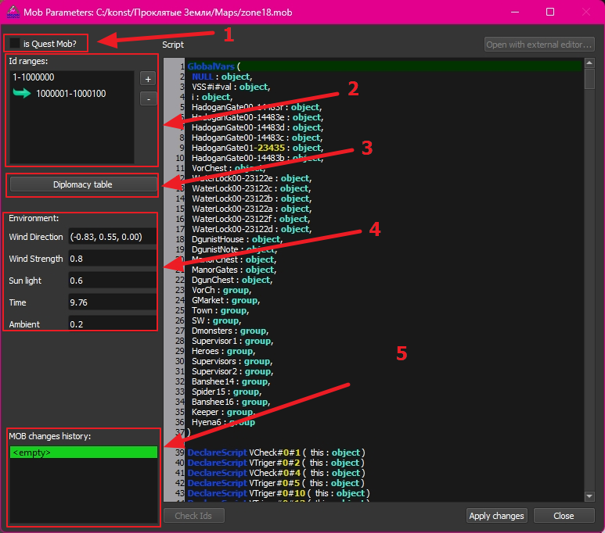

# 1- Switch the quest\basic *.MOB file. Base file is used to load diplomacy

# 2- Range of identifiers - they are used when creating new objects. Double-click to select the active one (however, the selection is not saved at the next opening, because there is nowhere to save it).

# 3- Table of diplomacy/relationships between groups of objects. By default, it is edited symmetrically, but you can change the behavior in the options.

# 4- Environment. Presumably needed to customize the visual component, in the editor does not affect anything.

# 5- History of parameter changes, the script part is not included here, it exists separately and has its own history of changes.

Editing and creating objects

## All parameters of the selected object are displayed in the table in the right part. The table is interactive, the parameters are changed mainly through it.

## One of the features of the editor is the ability to modify several selected objects at once, with different fields being marked as undefined/different. Parameters that do not overlap between objects will not be displayed at all. For example, units have a Database name field that other object types do not have.

## Some editing is added to separate hotkeys. For example, to move objects, the G key is used, after which the objects can be moved. To apply the move, press the left mouse button or Enter. When switching to the move mode, the following keys are available: X, Y, Z, all of them are responsible for their direction - you can use them to specify movement only along the selected axis. Besides, after selecting an axis you can also specify the number by which the object will be moved. As a result, after selecting objects and pressing G, X, 10, Enter, the objects will be moved by 10 points along the X axis. The rotation mode (R key) and zoom mode (T key) work in a similar way. Cancel the operation by pressing the Esc key.

Changing Map Id

The editor allows you to change the identifier for an object, but you should use it only when absolutely necessary, because Undo\Redo logic is attached to these identifiers.

Note: because of this feature, when loading a *.MOB file, duplicated Ids of objects are automatically checked and replaced. The game will crash if you try to display objects with the same Id, so this situation is not valid in any case.

## Undo\redo

The editor provides saving the history of operations. Some clarification is required here: it works for each element separately for each parameter. In other words, if you move 2 objects at an arbitrary distance, you will have to return 2 times for each object separately in the history. It is possible to return to several steps at once through the history menu located in Tools->History.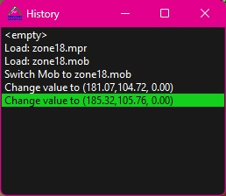

This point needs to be finalized in the future.

Copying a 3-component parameter

If you want to copy the full position of the object, rotation or complexion, you should stand on the joint area with components and press CTRL+C. When pasting, proceed in the same way, combination CTRL+V. The operation will be applied immediately.

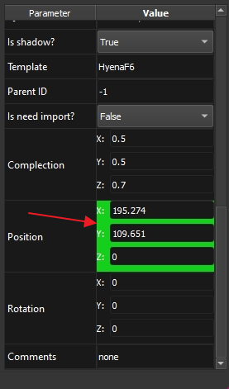

Access to unit parameters, replacing data from the database

Some parameters such as HP, MP, running speed, etc. can be overridden inside the *.MOB file. For this purpose, the unit should set the flag “Is Need Import?” to True, additional fields with parameters and equipment will appear.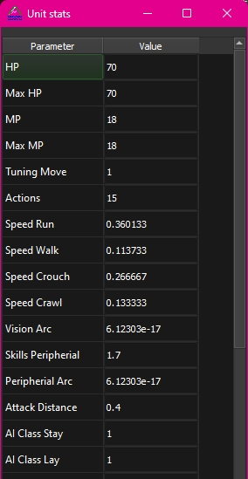

Creating a new object

The form of object creation can be accessed via CTRL+N key combination or via Edit->Create new object menu.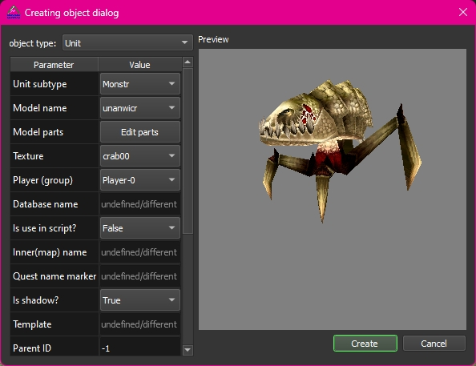

Here you can select the type of object and specify the desired parameters. The Create key will create an object on the game zone.

Sometimes it is necessary to change the object type. You can also do this through the object creation menu, having previously selected the original one.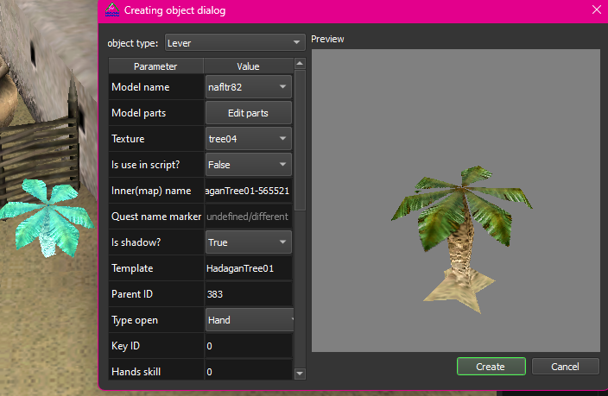

## Reset IDs

## Located in the Tools->Reset selected IDs menu. Resets IDs so that they start at 10 and above and go in order. The range of available values is read from the *.MOB file parameter.

## Resetting unit patrol points

After copying a unit, you still have its path? No problem, you can delete all patrol points in Edit->Unit->Reset logic paths menu.

## Generating random parameter values

Menu Tools->Randomize parameter. Allows you to randomize one of several parameters for selected objects. Only numeric values are available.

## Search

Accessed by CTRL+F key combination. Allows you to search for objects by exact match or substring of string parameters or range of numeric parameters.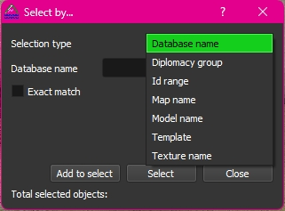

# Landscape editing

In version 0.3 ei_maper added the mode of drawing tiles (pieces of landscape). In order to start changing the landscape you need to open it (*.MPR), then switch to the mode of drawing tiles (key B). The panel with object parameters will be hidden to increase the usable area of the application. The example this time will be the city of Ingos and its surroundings (zone11.mpr) from the original game.

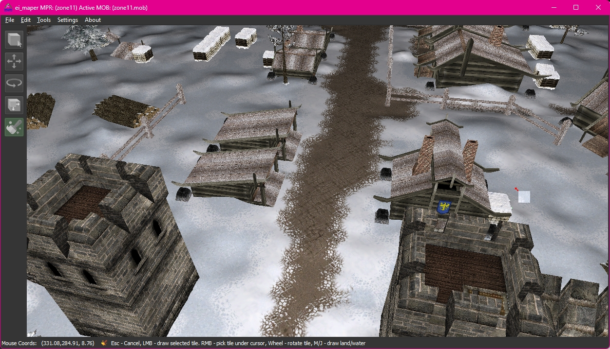

You may notice that when you enable this mode, the cursor has also changed. Now the cursor displays the tile that is underneath it. Also, the cursor is represented by a red arrow - this means editing the surface. For liquid the arrow will be green.

You can now grab the tile under the cursor with the RMB and start drawing with this tile with the LMB. In order to see what tiles are on the map, you need to open the Tiles Parameters, located in the Edit -> Tiles Parameters menu. This is how this window looks like for the zone11.mpr.

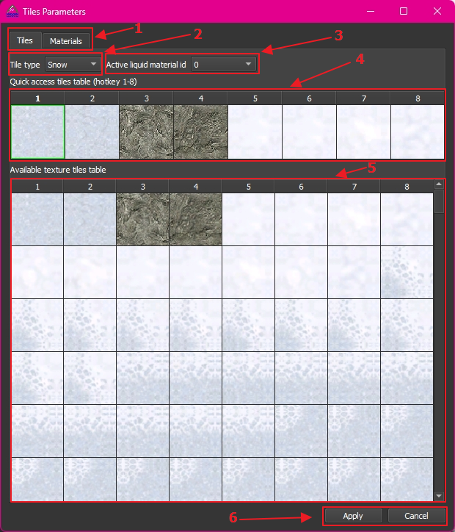

1. Switching between the tabs of tiles and materials. You can switch by using the CTRL+TAB shortcut.
2. The surface type assigned to the selected tile. Can be changed by selecting the desired type from the list.
3. The active material index for the liquid. Index -1 means that the liquid will be “off” in the game, although there will be geometry for it.
4. A set of quick access tiles with shortcuts keys 1-8. You do not have to open this form to use it.
5. Table of tiles. A set of all possible tiles for the landscape.
6. Keys to apply/cancel changes by tile and material type. Quick access tile set are not affected.

The materials panel from the second tab is a bit more modest. It contains information on materials for liquids, as well as parameters of animated tiles. Some of the parameters could not be “understood”, so I will leave it for your study.

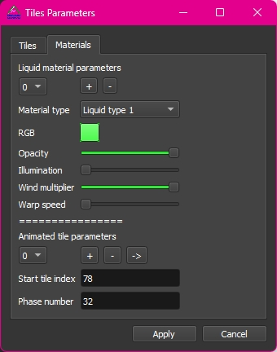

Some comments from what is known:

1. All liquids have color. However, to make it visible, you need to increase the Illumination parameter.
2. Animated tiles are a set of tiles that change each other in order (you cannot specify the time of change). In other words, a tile from the Start tile index will be changed by the next 32 tiles, including the start tile. Applies to both liquids and surfaces.

We now know how to select a tile through the tile table and from the surface, so we can safely add new roads, change old roads, etc. Sometimes the tiles need to be rotated, for this purpose the mouse wheel is used.

After a little practice, selecting tiles will be quite easy. Also, it is better to add frequently used tiles to the quick access bar and use keys 1-8 to select them. Here is a small example of how the new road branch looks like

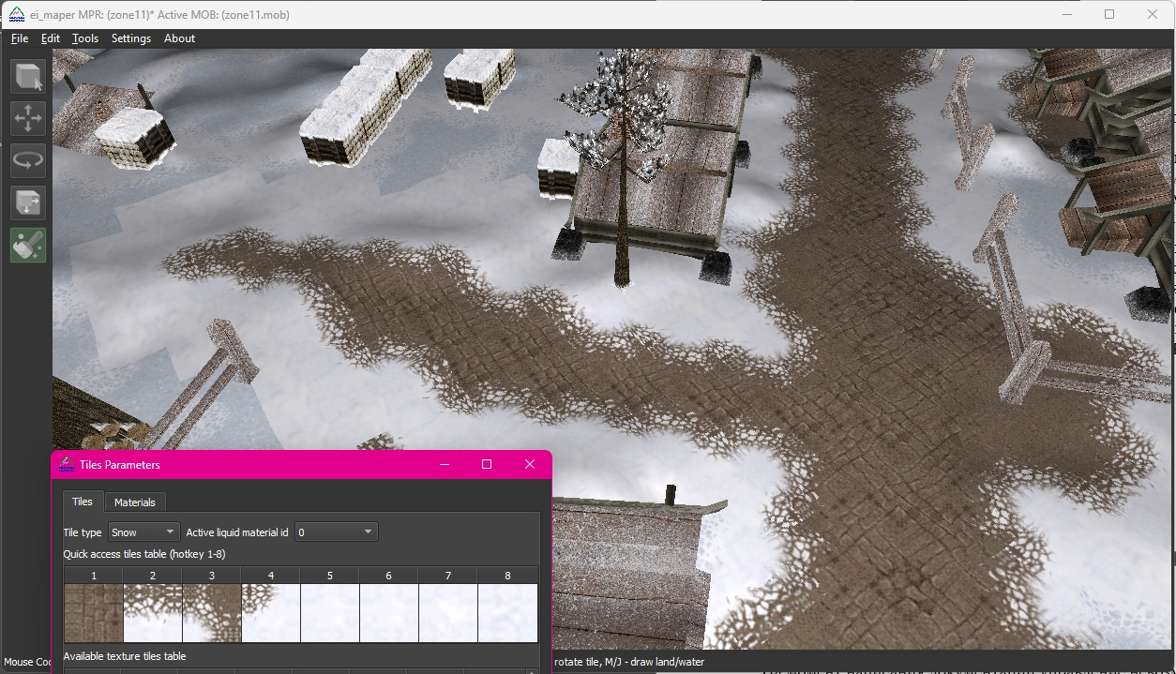

The transition between the white snow and the blue snow isn't very good, is it? We need to find suitable tiles for them too!

Undo\redo hotkey commands CTRL+Z, CTRL+Y are supported for drawing tails.

Note: editing of landscape geometry is not implemented at the moment, only changing of tiles.

## A few words about liquids

The entire landscape is divided into sectors of equal size. A sector always contains surface geometry, but may not contain liquid. Thus, the liquid may not be defined everywhere or may not be present at all. However, the liquid also has geometry that is the size of the entire sector, so to remove the extra water the -1 index is used (you can select the material type for the tile brush in the Tiles Parameters window). Please note that even if you set the water tile index -1 and it will not be visible in the game, the character will still not be able to pass under it, for this you need to change the geometry. The original landscapes, in addition to the -1 index, also used different tiles than water, presumably for visual perception. This is how the lake near the city of Ingos looks like if you hide the surface (M key):

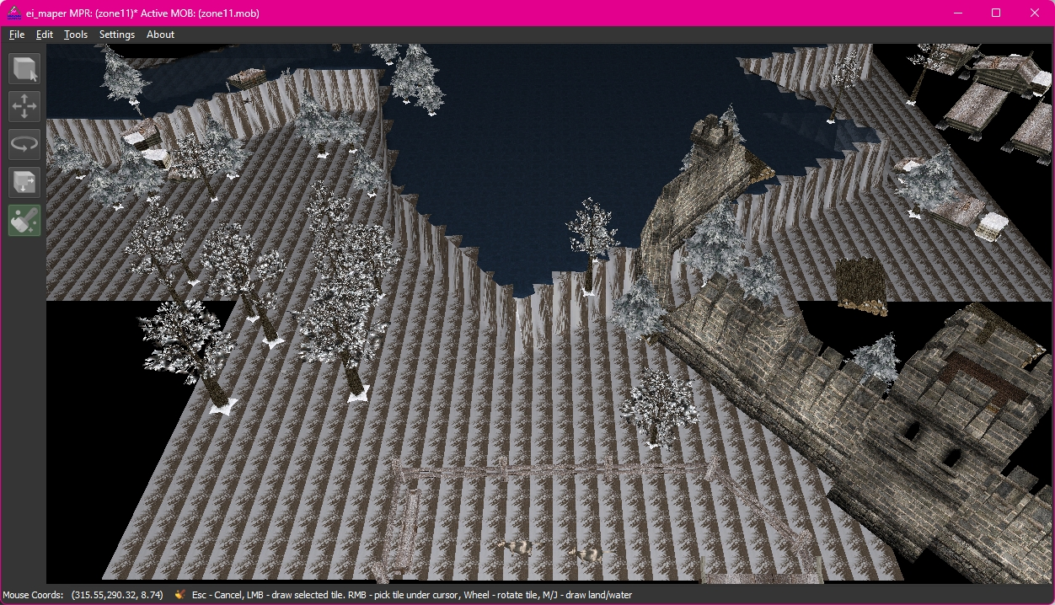

The indexes are clear, the geometry is also clear. There is still a question with glare on water. This is where animated tiles come in handy. In the material parameters of the section with animated tiles there is an arrow button, which will show on the set of tiles what the numbers of the animated tile are responsible for.

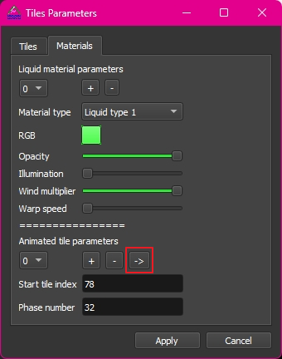

In this case, it will be like this:

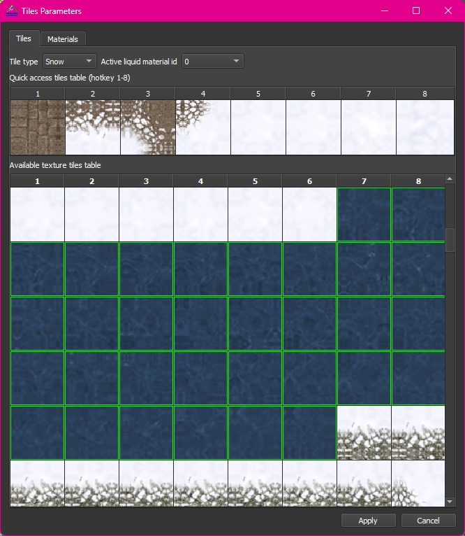

Here, the tiles that will alternate with each other are highlighted. You can add your range from the context menu in the table.

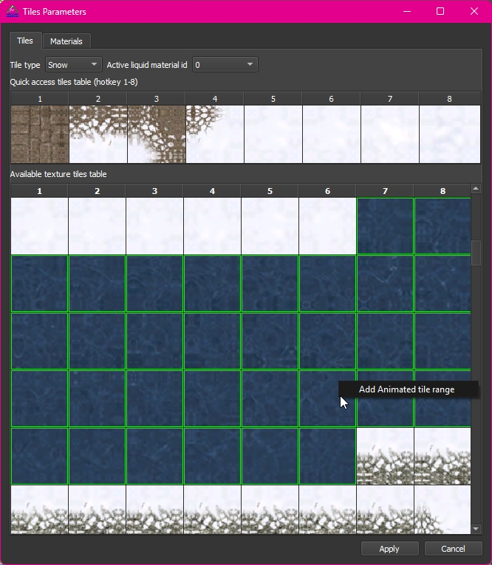

# Hotkeys

At the time of writing the documentation, the control cannot be changed. It is fixed in the code. So, here is the list of all hotkeys that are available in the editor

1. Object selection mode (default)
   1. CTRL+A - select all objects on the current *.MOB file
   2. W, A, S, D, Q, E - move around the game zone
   3. CTRL+R - reset the camera to its original position
   4. .(dot) - move to the selected object
   5. DEL - delete selected objects
   6. CTRL+Z - return the operation performed
   7. CTRL+Y - repeat the last operation
   8. CTRL+M - window for editing *.MOB file parameters
   9. CTRL+TAB - switch mode to unit logic mode and vice versa
   10. CTRL+T - switching the active *.MOB file
   11. CTRL+C - copy selected objects (copying is done through the file, so the clipboard will not be affected)
   12. CTRL+V - paste selected objects (pasting takes into account the cursor position when copying). Note: after copying objects, the mode switches to shift, so if you want to keep the original positions, you just need to press the Esc key after pasting or the left mouse button to apply the shift.
   13. CTRL+X - cut objects
   14. CTRL+S – save active MOB file
   15. CTRL+SHIFT+S – save MPR
   16. U - unload active *.MOB/*.MPR.
   17. G - switch to the mode of moving objects
   18. R - switch to the object rotation mode
   19. T - switch to the object scaling mode
   20. H - hide object
   21. ALT+H - display hidden objects
2. Editing mode (move, rotate, zoom)
   1. X, Y, Z - axis selection
   2. Esc – cancel
3. Unit logic mode

# P - add a patrol point (for behavior type: Path). Note: you can add points relative to any selected patrol point, as well as do it for multiple units. If a magic trap is selected, it will create a trap activation zone.

# L - add an inspection point (for the selected patrol point). Note: if magic trap is selected, will add a spell activation point for area spells.

# DEL - delete selected logic points